Nama : Muhammad Ridho

Kelas : 4IA06

NPM : 51421055

Materi : Konsep Model – View – Controller (MVC)

Mata Praktikum : Rekayasa Perangkat Lunak 2

ACTIVITY 3

SOAL

1. Jelaskan bagaimana cara membuat database “mvc_db” menggunakan XAMPP?
2. Screenshot hasil codingan kalian lengkap dengan window Projects, Navigator, dan Outputnya.

JAWABAN

1. Pertama, buka XAMPP lalu nyalakan Apache dan MySQL.

Kedua, masuk ke admin MySQL.

Ketiga, buat database mvc_db.

Keempat, run query untuk membuat table mahasiswa, lalu tekan go.

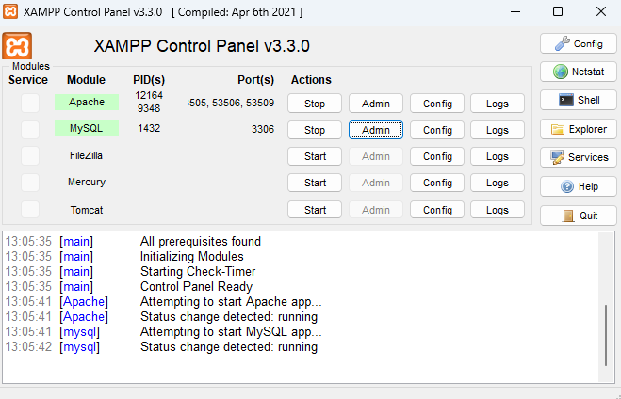

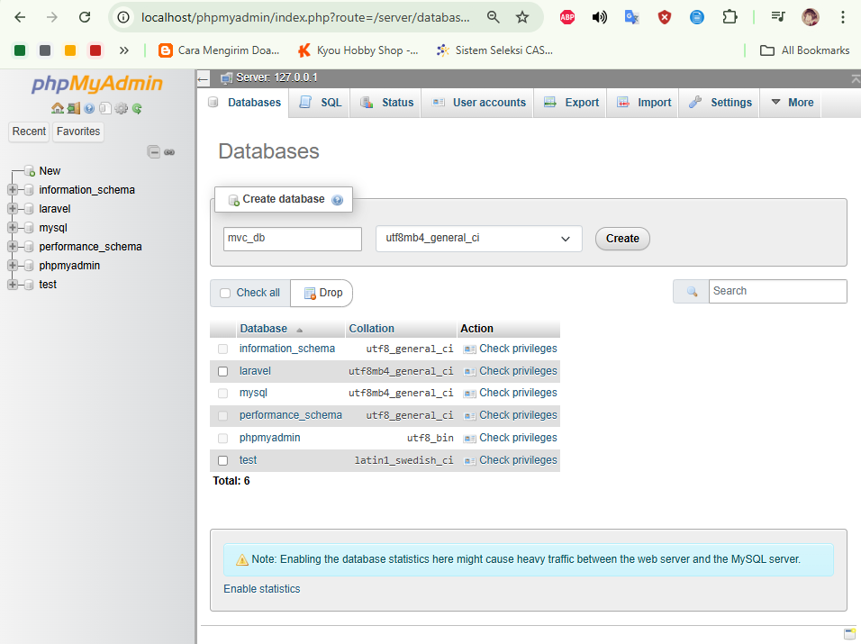

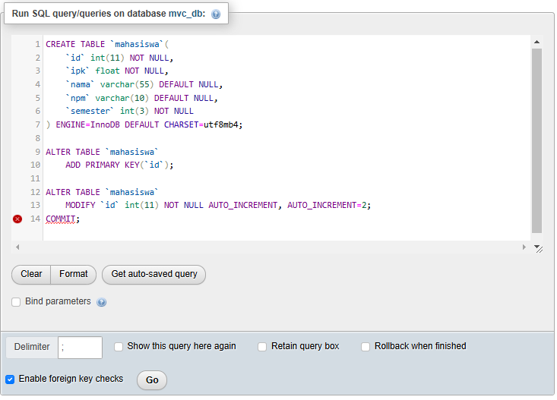

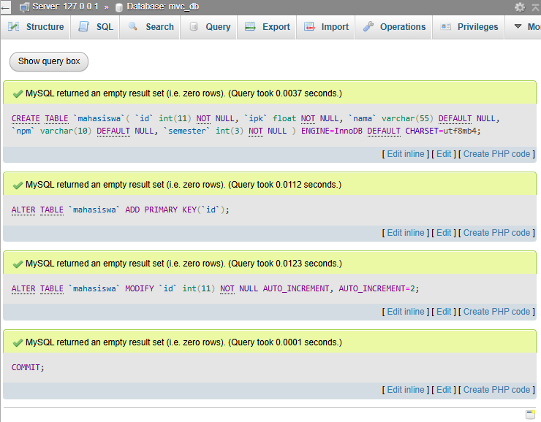

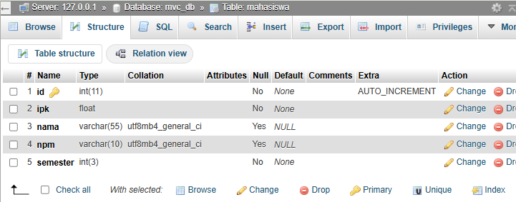

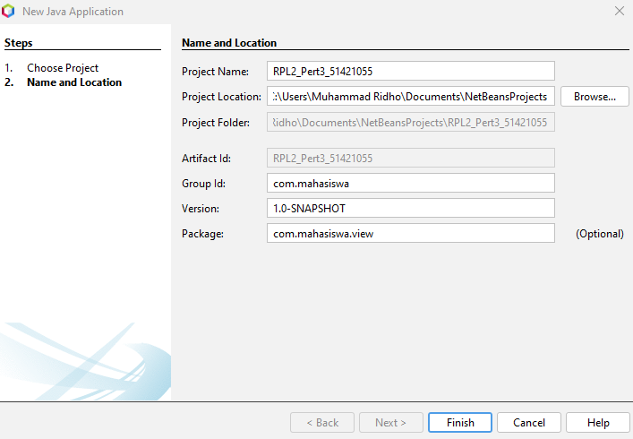

**MahasiswaView.java**

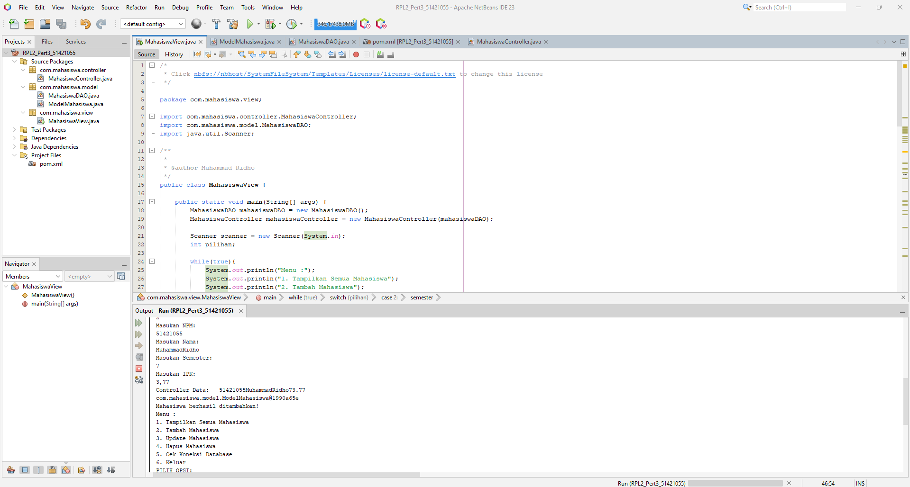

Source Code:

/*

* Click nbfs://nbhost/SystemFileSystem/Templates/Licenses/license-default.txt to change this license

*/

package com.mahasiswa.view;

import com.mahasiswa.controller.MahasiswaController;

import com.mahasiswa.model.MahasiswaDAO;

import java.util.Scanner;

/**

*

* @author Muhammad Ridho

*/

public class MahasiswaView {

public static void main(String[] args) {

MahasiswaDAO mahasiswaDAO = new MahasiswaDAO();

MahasiswaController mahasiswaController = new MahasiswaController(mahasiswaDAO);

Scanner scanner = new Scanner(System.in);

int pilihan;

while(true){

System.out.println("Menu :");

System.out.println("1. Tampilkan Semua Mahasiswa");

System.out.println("2. Tambah Mahasiswa");

System.out.println("3. Update Mahasiswa");

System.out.println("4. Hapus Mahasiswa");

System.out.println("5. Cek Koneksi Database");

System.out.println("6. Keluar");

System.out.println("PILIH OPSI: ");

pilihan = scanner.nextInt();

scanner.nextLine();

switch(pilihan){

case 1:

mahasiswaController.displayAllMahasiswa();

break;

case 2:

System.out.println("Masukan NPM: ");

String npm = scanner.next();

System.out.println("Masukan Nama: ");

String nama = scanner.next();

System.out.println("Masukan Semester: ");

int semester = scanner.nextInt();

System.out.println("Masukan IPK: ");

float ipk = scanner.nextFloat();

mahasiswaController.addMahasiswa(npm, nama, semester, ipk);

break;

case 3:

System.out.println("Masukan ID Mahasiswa: ");

int id = scanner.nextInt();

scanner.nextLine();

System.out.println("Masukan NPM: ");

String npmBaru = scanner.next();

System.out.println("Masukan Nama: ");

String namaBaru = scanner.next();

System.out.println("Masukan Semester");

int semesterBaru = scanner.nextInt();

System.out.println("Masukan IPK: ");

float ipkBaru = scanner.nextFloat();

mahasiswaController.updateMahasiswa(id, npmBaru, namaBaru, semesterBaru, ipkBaru);

break;

case 4:

System.out.println("Masukan ID Mahasiswa yg Ingin Dihapus: ");

int idHapus = scanner.nextInt();

mahasiswaController.deleteMahasiswa(idHapus);

break;

case 5:

mahasiswaController.checkDatabaseConnection();

break;

case 6:

mahasiswaController.closeConnection();

System.out.println("Program selesai");

return;

default:

System.out.println("Input Tidak Valid");

}

}

}

}

**ModelMahasiswa.java**

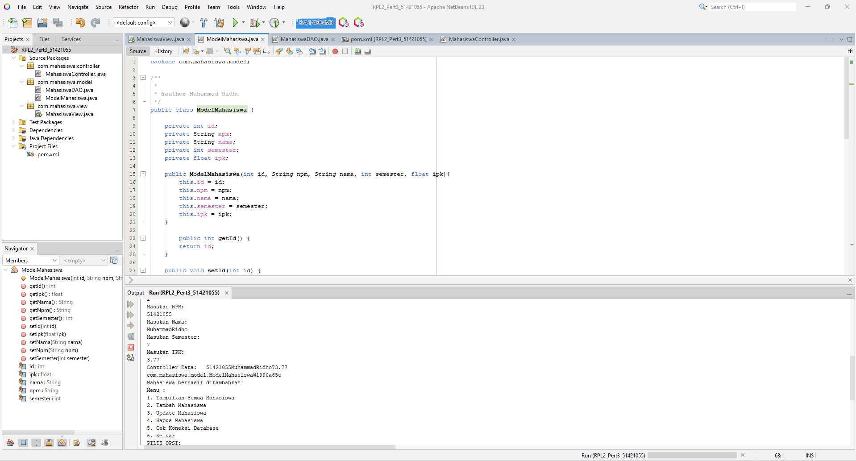

Source Code:

package com.mahasiswa.model;

/**

*

* @author Muhammad Ridho

*/

public class ModelMahasiswa {

private int id;

private String npm;

private String nama;

private int semester;

private float ipk;

public ModelMahasiswa(int id, String npm, String nama, int semester, float ipk){

this.id = id;

this.npm = npm;

this.nama = nama;

this.semester = semester;

this.ipk = ipk;

}

public int getId() {

return id;

}

public void setId(int id) {

this.id = id;

}

public String getNpm() {

return npm;

}

public void setNpm(String npm) {

this.npm = npm;

}

public String getNama() {

return nama;

}

public void setNama(String nama) {

this.nama = nama;

}

public int getSemester() {

return semester;

}

public void setSemester(int semester) {

this.semester = semester;

}

public float getIpk() {

return ipk;

}

public void setIpk(float ipk) {

this.ipk = ipk;

}

}

**MahasiswaDAO.java**

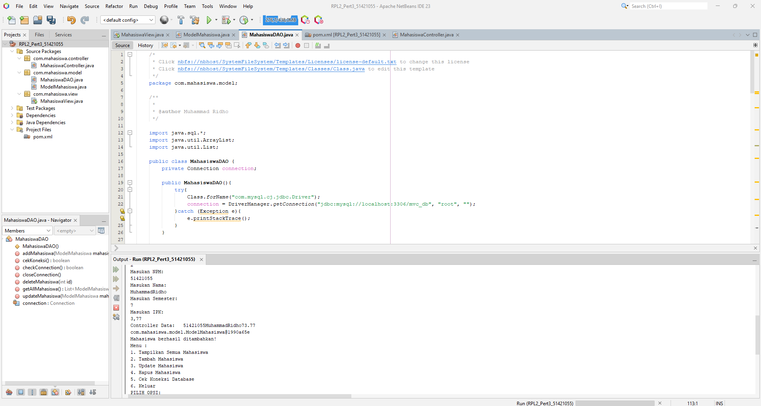

Source Code:

/*

* Click nbfs://nbhost/SystemFileSystem/Templates/Licenses/license-default.txt to change this license

* Click nbfs://nbhost/SystemFileSystem/Templates/Classes/Class.java to edit this template

*/

package com.mahasiswa.model;

/**

*

* @author Muhammad Ridho

*/

import java.sql.*;

import java.util.ArrayList;

import java.util.List;

public class MahasiswaDAO {

private Connection connection;

public MahasiswaDAO(){

try{

Class.forName("com.mysql.cj.jdbc.Driver");

connection = DriverManager.getConnection("jdbc:mysql://localhost:3306/mvc_db", "root", "");

}catch (Exception e){

e.printStackTrace();

}

}

public boolean cekKoneksi () {

try{

if(connection != null && connection.isClosed());

return true;

}catch (SQLException e) {

e.printStackTrace();

}

return false;

}

public void addMahasiswa(ModelMahasiswa mahasiswa){

String sql = "INSERT INTO mahasiswa (npm, nama, semester, ipk) VALUES (?, ?, ?, ?)";

try{

PreparedStatement pstmt = connection.prepareStatement(sql);

pstmt.setString(1, mahasiswa.getNpm());

pstmt.setString(2, mahasiswa.getNama());

pstmt.setInt(3, mahasiswa.getSemester());

pstmt.setFloat(4, mahasiswa.getIpk());

pstmt.executeUpdate();

} catch(SQLException e){

e.printStackTrace();

}

}

public List<ModelMahasiswa> getAllMahasiswa(){

List<ModelMahasiswa> mahasiswaList = new ArrayList<>();

String sql = "SELECT * FROM mahasiswa";

try{

Statement stmt = connection.createStatement();

ResultSet rs = stmt.executeQuery(sql);

while(rs.next()){

mahasiswaList.add(new ModelMahasiswa(

rs.getInt("id"),

rs.getString("npm"),

rs.getString("nama"),

rs.getInt("semester"),

rs.getFloat("ipk")

));

}

} catch(SQLException e){

e.printStackTrace();

}

return mahasiswaList;

}

public void updateMahasiswa(ModelMahasiswa mahasiswa){

String sql = "UPDATE mahasiswa SET npm = ?, nama = ?, semester = ?, ipk = ? WHERE id = ?";

try{

PreparedStatement pstmt = connection.prepareStatement(sql);

pstmt.setString(1, mahasiswa.getNpm());

pstmt.setString(2, mahasiswa.getNama());

pstmt.setInt(3, mahasiswa.getSemester());

pstmt.setFloat(4, mahasiswa.getIpk());

pstmt.setInt(5, mahasiswa.getId());

pstmt.executeUpdate();

} catch(SQLException e){

e.printStackTrace();

}

}

public void deleteMahasiswa(int id){

String sql = "DELETE FROM mahasiswa WHERE id = ?";

try{

PreparedStatement pstmt = connection.prepareStatement(sql);

pstmt.setInt(1, id);

pstmt.executeUpdate();

} catch(SQLException e){

e.printStackTrace();

}

}

// Method untuk menutup koneksi database

public void closeConnection() {

try {

if (connection != null) {

connection.close();

}

} catch (SQLException e) {

e.printStackTrace();

}

}

public boolean checkConnection() {

throw new UnsupportedOperationException("Not supported yet."); // Generated from nbfs://nbhost/SystemFileSystem/Templates/Classes/Code/GeneratedMethodBody

}

}

**Pom.xml**

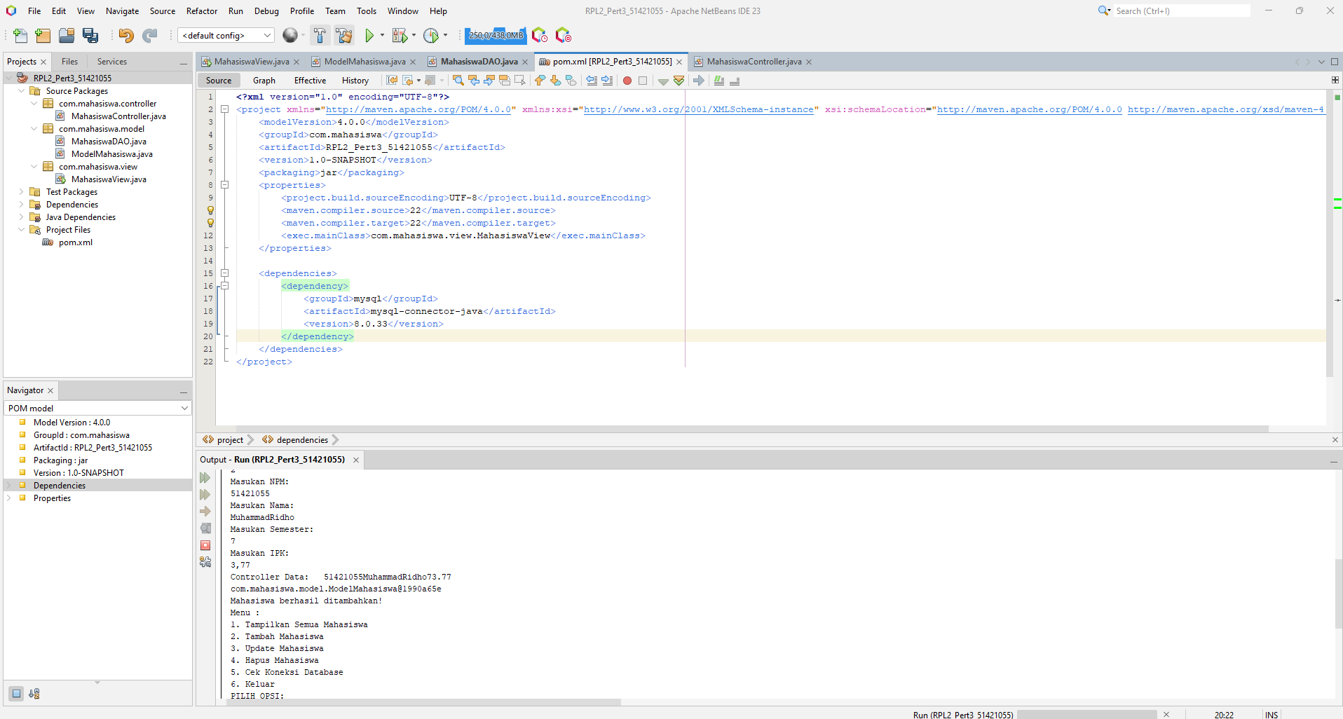

Source Code:

<?xml version="1.0" encoding="UTF-8"?>

<project xmlns="http://maven.apache.org/POM/4.0.0" xmlns:xsi="http://www.w3.org/2001/XMLSchema-instance" xsi:schemaLocation="http://maven.apache.org/POM/4.0.0 http://maven.apache.org/xsd/maven-4.0.0.xsd">

<modelVersion>4.0.0</modelVersion>

<groupId>com.mahasiswa</groupId>

<artifactId>RPL2_Pert3_51421055</artifactId>

<version>1.0-SNAPSHOT</version>

<packaging>jar</packaging>

<properties>

<project.build.sourceEncoding>UTF-8</project.build.sourceEncoding>

<maven.compiler.source>22</maven.compiler.source>

<maven.compiler.target>22</maven.compiler.target>

<exec.mainClass>com.mahasiswa.view.MahasiswaView</exec.mainClass>

</properties>

<dependencies>

<dependency>

<groupId>mysql</groupId>

<artifactId>mysql-connector-java</artifactId>

<version>8.0.33</version>

</dependency>

</dependencies>

</project>

**MahasiswaController.java**

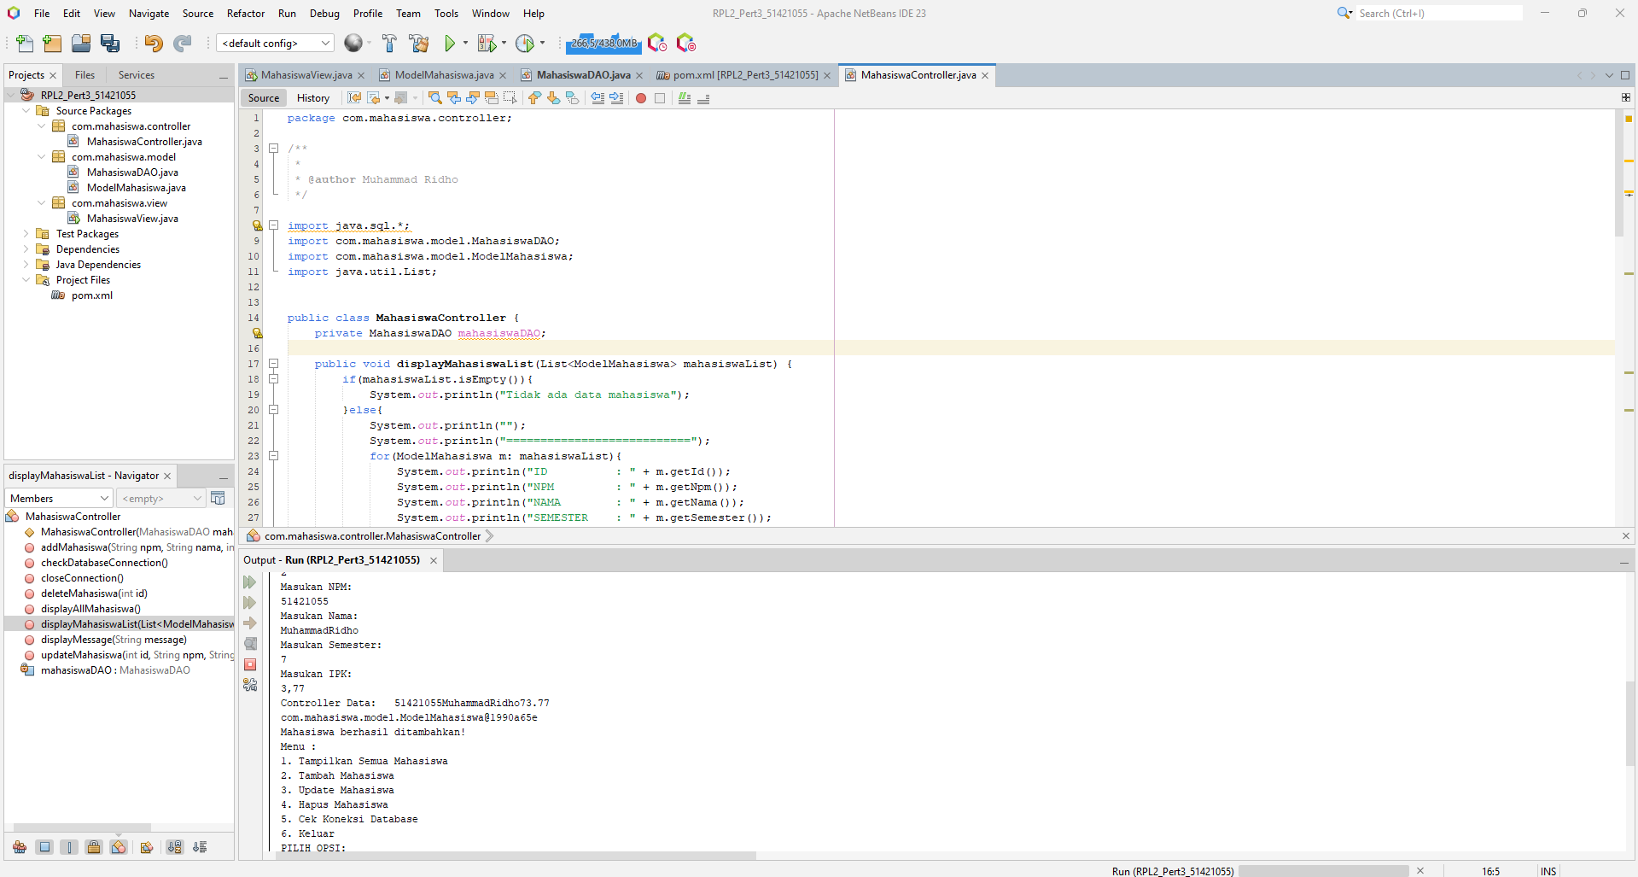

Source Code:

package com.mahasiswa.controller;

/**

*

* @author Muhammad Ridho

*/

import java.sql.*;

import com.mahasiswa.model.MahasiswaDAO;

import com.mahasiswa.model.ModelMahasiswa;

import java.util.List;

public class MahasiswaController {

private MahasiswaDAO mahasiswaDAO;

public void displayMahasiswaList(List<ModelMahasiswa> mahasiswaList) {

if(mahasiswaList.isEmpty()){

System.out.println("Tidak ada data mahasiswa");

}else{

System.out.println("");

System.out.println("===========================");

for(ModelMahasiswa m: mahasiswaList){

System.out.println("ID : " + m.getId());

System.out.println("NPM : " + m.getNpm());

System.out.println("NAMA : " + m.getNama());

System.out.println("SEMESTER : " + m.getSemester());

System.out.println("IPK : " + m.getIpk());

System.out.println("===========================");

}

displayMessage("Mahasiswa berhasi ditampilkan");

}

}

public void displayMessage(String message){

System.out.println(message);

}

public MahasiswaController(MahasiswaDAO mahasiswaDAO){

this.mahasiswaDAO = mahasiswaDAO;

}

public void checkDatabaseConnection(){

boolean isConnected = mahasiswaDAO.cekKoneksi();

if (isConnected){

displayMessage("Koneksi ke db berhasil");

} else{

displayMessage("Koneksi DB Gagal");

}

}

public void displayAllMahasiswa(){

List<ModelMahasiswa> mahasiswaList = mahasiswaDAO.getAllMahasiswa();

displayMahasiswaList(mahasiswaList);

}

public void addMahasiswa(String npm, String nama, int semester, float ipk){

ModelMahasiswa mahasiswaBaru = new ModelMahasiswa(0, npm, nama, semester, ipk);

System.out.println("Controller Data: " + npm + nama + semester + ipk);

System.out.println(mahasiswaBaru);

mahasiswaDAO.addMahasiswa(mahasiswaBaru);

displayMessage("Mahasiswa berhasil ditambahkan!");

}

public void updateMahasiswa(int id, String npm, String nama, int semester, float ipk){

ModelMahasiswa mahasiswaBaru = new ModelMahasiswa(id, npm, nama, semester, ipk);

mahasiswaDAO.updateMahasiswa(mahasiswaBaru);

displayMessage("Mahasiswa berhasil diperbarui!");

}

public void deleteMahasiswa(int id){

mahasiswaDAO.deleteMahasiswa(id);

displayMessage("Mahasiswa Berhasil Dihapus!");

}

public void closeConnection() {

mahasiswaDAO.closeConnection();

}

}

**OUTPUT:**

